**TASK 01: Execute all example code and attach output in your lab---------**

**Solution:**

{

DateTime dt = DateTime.Now;

Console.WriteLine("---------DATE AND TIME--------");

Console.WriteLine("{0:dd-MM-yyyy hh:mm:ss}",dt);

Console.WriteLine("\n-----LEFT AND RIGHT SPACES------");

Console.WriteLine("{0,10} {1,10}", 121, 122);

Console.WriteLine("{0,-10}{1,-10}",132,129);

Console.WriteLine("\n--------DECIMAL----------");

Console.WriteLine("{0,-10:D6}{1,-10:D7}",132,129);

Console.WriteLine("\n--------CURRENCY-----------");

Console.WriteLine("{0:C}",2345);

Console.WriteLine("{0:N}",27384);

Console.WriteLine("\n------PERCENTAGE--------");

Console.WriteLine("{0:P}",73534);

Console.WriteLine("\n-------EXPONENT---------");

Console.WriteLine("{0:E}",5343.28737);

Console.WriteLine("\n------FIXED POINT-------");

Console.WriteLine("{0,10:F} {1,10:F}",5342,6344);

}

**Output:**

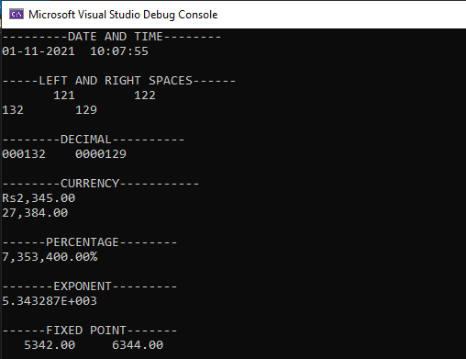

**TASK 02:** **Create a small form which take input from an employee of any company and display profile in formatted manner------**

**Solution:**

string n, f, h, d;

int S;

double p;

Console.Write("ENTER YOUR NAME: ");

n = Console.ReadLine();

Console.Write("ENTER YOUR FATHER NAME:");

f = Console.ReadLine();

Console.Write("ENTER YOUR PHONE NUMBER: ");

p = Convert.ToDouble(Console.ReadLine());

Console.Write("ENTER YOUR DESIGNATION: ");

d= Console.ReadLine();

Console.Write("ENTER YOUR DATE OF HIRING: ");

h = Console.ReadLine();

Console.Write("ENTER YOUR SALARY: ");

S =Convert.ToInt32(Console.ReadLine());

Console.Clear();

Console.WriteLine("****************************");

Console.WriteLine("\t MY PROFILE");

Console.WriteLine("");

Console.WriteLine("NAME: " + n);

Console.WriteLine("FATHER NAME: " + f);

Console.WriteLine("PHONE NUMBER: " + p);

Console.WriteLine("DESIGNATION: " + d);

Console.WriteLine("DATE OF HIRING: " + h);

Console.WriteLine("SALARY: {0:C}",S);

Console.WriteLine("****************************");

**Output:**

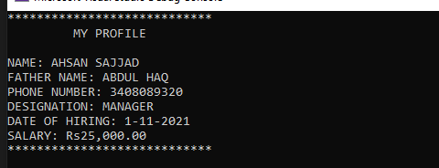

**TASK 03: Create a simple C# program in which you will display the restaurant payment bill in formatted manner-----**

**Solution:**

Console.WriteLine("\t\tMEHRAN HOTEL");

Console.WriteLine("\t\tMAIN ROAD SF");

Console.WriteLine("\t\tKARACHI");

double biryani, pizza;

biryani = 150;

pizza = 700;

double total = biryani + pizza;

double tax = 4.99;

double gravity = 3.39;

double Tdue = total + tax + gravity;

DateTime dt = DateTime.Now;

Console.WriteLine("\t\t\t\t{0:dd/MM/yyyy HH:mm:ss}",dt);

Console.WriteLine("---------------------------------------------------");

Console.WriteLine("Table no 201\tchk: #1111\tguest: 2");

Console.WriteLine("---------------------------------------------------");

Console.WriteLine("\n\n\tbiryani {0:C}",biryani);

Console.WriteLine("\tpizza {0:C}", pizza);

Console.WriteLine("\ttotal {0:C}", total);

Console.WriteLine("\ttax {0:C}",tax);

Console.WriteLine("\tgravity {0:C}",gravity);

Console.WriteLine("\tDue TOTAL {0:C}",Tdue);

Console.WriteLine("\n\n\n\t\tTHANK YOU FOR DINING WITH US");

Console.WriteLine("\t\tplease come again");

**Output:**

